**ECMP Machine ID**

* Open ECA Registration page. Machine id will be shown on top of the page.

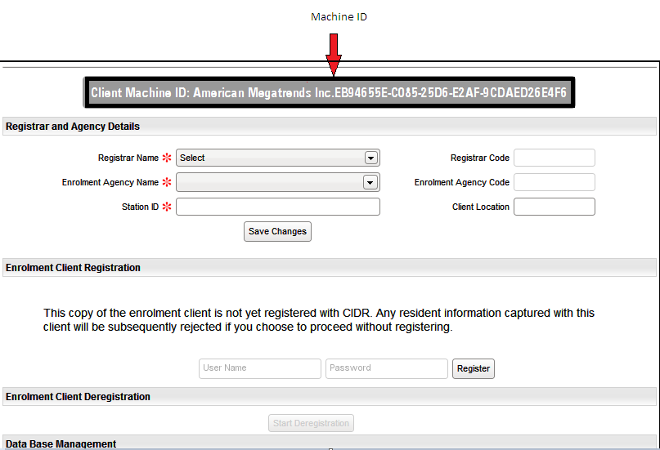

**UCL Machine ID**

* It is available in the Registration/De-registration page

